EMAIL TEMPLATE #1: PURCHASE

Instructions:

First, pick any one of your available purchase mortgage funnels and... edit the domain, the call-to-action, and the background image so it looks something like this (recommended):

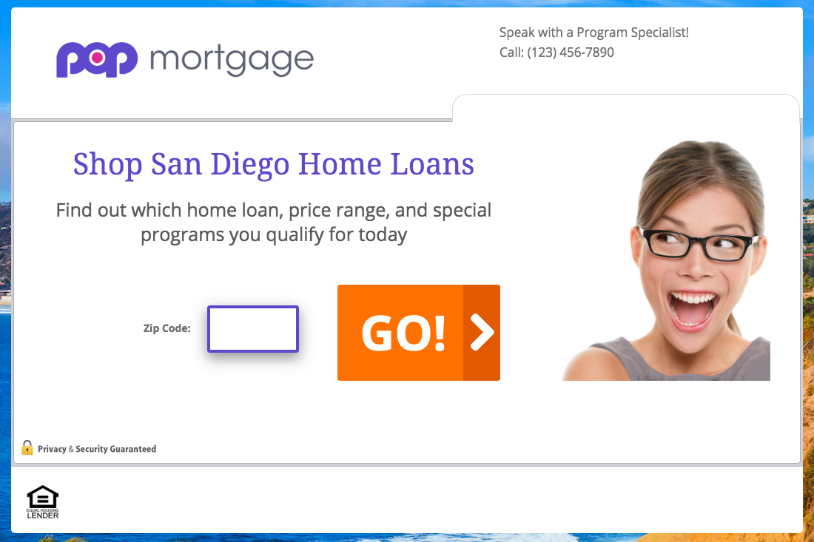

Then, copy-and-paste the email subject line and body copy into your email software, and customize anything highlighted yellow: (Note: embed a link to your funnel where it says “try it out and let me know what you think.”)

Last, save what you’ve created as a template inside your email software, and email any past client you’ve helped purchase or refinance a home in the last 3 years.

Email Subject Line:

! - Homes

Email Body Copy:

Hi First Name,

Are you thinking about buying a home sometime soon?

If so, try our new “Area Home Loan Finder” tool (takes about 60 seconds):

www.your-funnel-link.com

It’s NOT a mortgage application — no private info needed...

It’s a short questionnaire so you can find out which home loan and price range you qualify for… including any down payment assistance, savings or incentives...

So whether you’re looking to start shopping in a week, a month, or a year — this will help you focus your home search and be better prepared for the BIG purchase!

Anyway, try it out and let me know what you think.

Sincerely,

Email Signature

P.S. If you would prefer to speak with me directly, reply to this email or call me at (123) 456-7890.

