EMAIL TEMPLATE #2: REFINANCE

Instructions:

First, pick any one of your available refinance mortgage funnels and... edit the domain, the call-to-action, and the background image so it looks something like this (recommended):

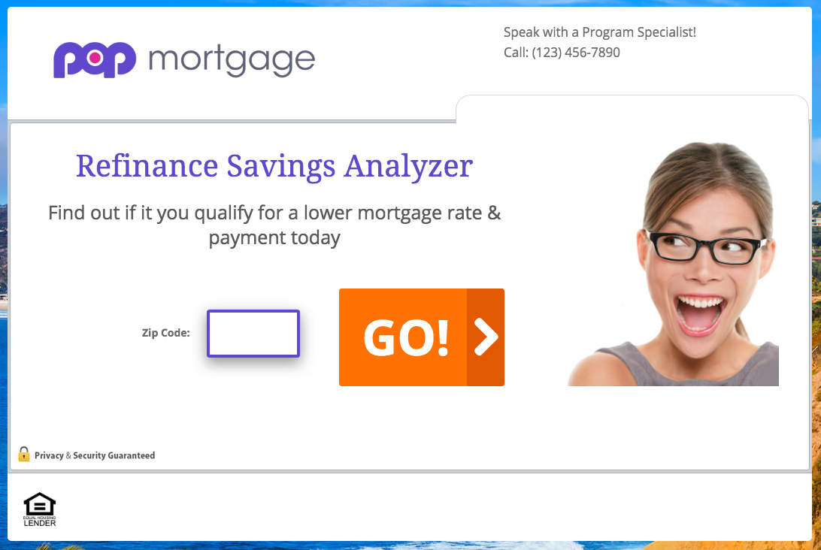

Then, copy-and-paste the email subject line and body copy into your email software, and customize anything highlighted yellow. (Note: embed a link to your funnel where it says “try it out and let me know what you think.”)

Last, save what you’ve created as a template inside your email software, and email any past client you’ve helped purchase or refinance a home in the last 3 years.

Email Subject Line:

! - Refinance

Email Body Copy:

Hi First Name,

Based on my records, it looks like now might be a good time to refinance your mortgage and lower your monthly payment and/or take money out...

Is this something you might be interested in?

If so, try our new “Refinance Savings Analyzer” tool (takes about 60 seconds):

www.your-funnel-link.com

It’s NOT a loan application — no private info needed...

It’s a short questionnaire so you can find out if it makes sense to refinance your mortgage based on today’s low rates… including any little or no money out of pocket options!

Anyway, try it out and let me know what you think.

If the numbers look good, we can take action before rates go up again.

Sincerely,

Email Signature

P.S. If you would prefer to speak with me directly, reply to this email or call me at (123) 456-7890.

